**P1**

**Introduction**

In this report, I will be explaining to my fellow employees by what is meant by the ***programming paradigms procedural, event driven, object oriented, mark-up and scripting.*** I will be giving examples and explain the limits of each of them.

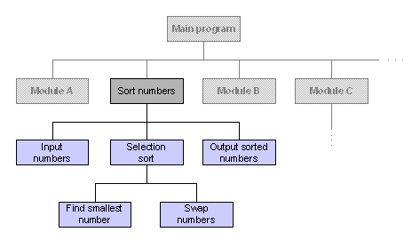**Programming paradigms procedural** is a program that designs programs upon the shapes. It uses paradigms to help it. Paradigms have many types such as imperative, functional, logic, object-oriented. They are many benefits over this programme. This is easier to read and flexible. It has a good design for the facilities to be used. This programme is used in COBOL. The disadvantage of using this programme is the codes is hard to write. Therefore, it is hard to reuse the codes.

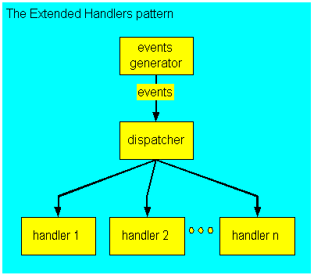

**Event-driven programme** (EDP) is a programme paradigm that determines the flow of the program. The flows could be sensor outputs; the users actions (mouse clicks, keyboard pressing) or messages from one program to the other. They are two sectors of even-driven program. The first is selection and second is handling. The advantage of this program is that it is faster than object oriented. In addition, it is flexible. It has a range of features that can do different things. However, the disadvantage is that it is very complex and hard to use for users. An example of where EDP is used is Java.

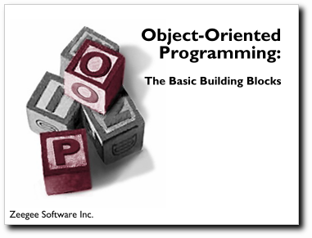**Object** **oriented** tends to program ‘objects’. This is used in Java. Many developers use OOP language because they believe that it is suitable for them to use it. The advantage of using OPP is that, as many of other programming languages, it is easy to use. This mimics the real word, as it makes easier for programmers to program new things to grasp. On the other hand, the performance of OOP is very slow. It tends to require more memory than any other programming language. Programmers who tend to be brought up using OOP, it takes longer for them to create.

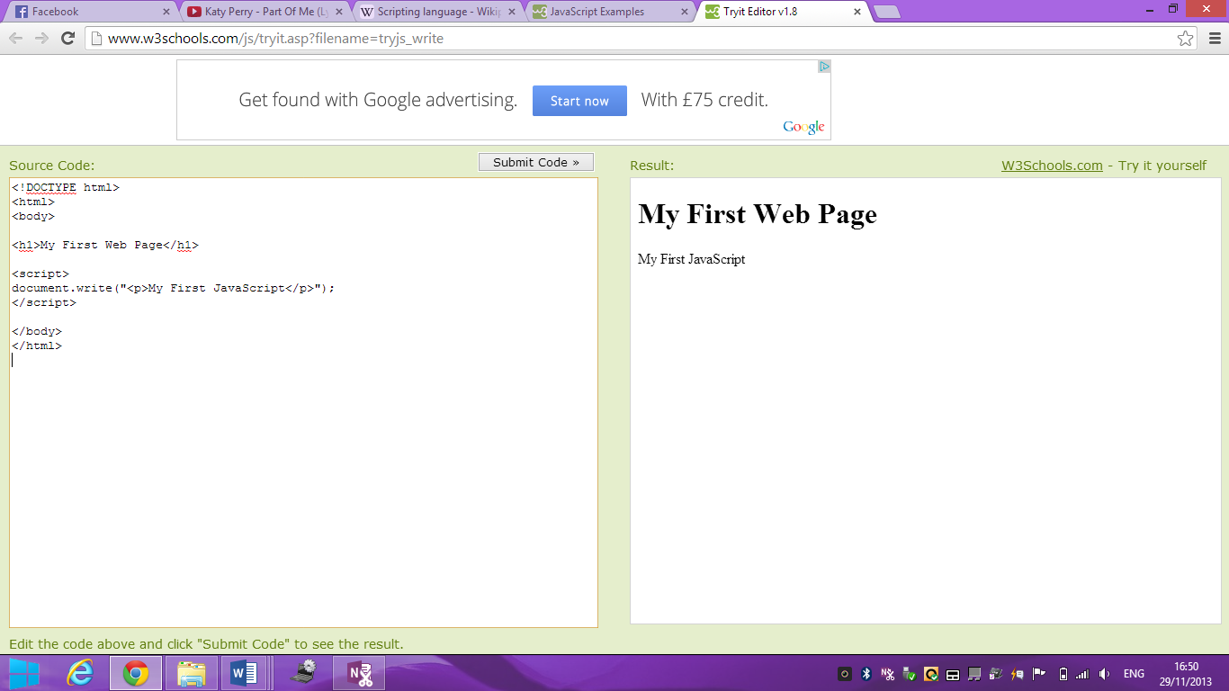**Mark-up** language does not contain instructions such as loops, selection, iteration but they give out instructions to control the format. Mark-up language is best known by the use of HTML. HTML is used to create webpages. The code needs to be inserted within HTML by using script language. The advantage of using mark-up language is that it is easier for the web application however the most frequent browser, Microsoft Internet Explorer, does not even support HTML. As I have repeated it many times, an example that mark-up language is used is in HTML.

[](http://www.google.co.uk/url?sa=i&rct=j&q=&esrc=s&frm=1&source=images&cd=&cad=rja&docid=oSOelSgblPyCUM&tbnid=2FYJnb0uzXqgnM:&ved=0CAUQjRw&url=http://www.computingverticals.com/496/what-does-markup-language-mean/&ei=75ScUtKeEOGI7AamxoCQDQ&psig=AFQjCNFYfCXZcy8upXpsU8uFATCRPdHc3w&ust=1386079830932085)**Scripting** is a form of programming language that is used on a web page. This can interpret tasks one-by-one by a human user. This is very fast to pick up. An example of scripting programme could be JavaScript in Visual Basics. You can use scripting whilst creating the webpage. The image below demonstrates how the codes of scripting looks like. As I have stated before, it is very fast to pick up. Therefore, the advantage is that it is easier to write the code. This allows complex tasks to be performed in a matter of minutes. Lastly, editing the code and running the code is easy. However, it is slow.

***All of the languages in each section:***

|  |  |
| --- | --- |
| **Types** | **Examples** |
| Procedural languages | Cobol |
| Object-oriented | Java |
| Visual | Visual basic |
| Scripting | Java script |
| Mark-up | HTML |

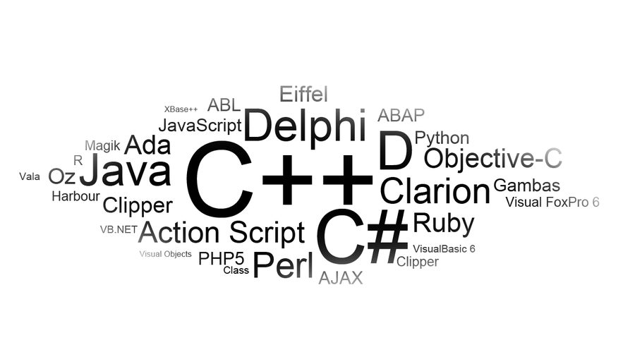

[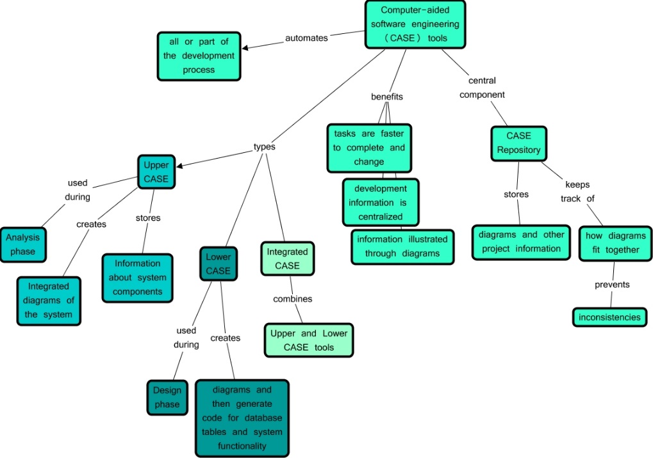](http://www.google.co.uk/url?sa=i&rct=j&q=&esrc=s&frm=1&source=images&cd=&cad=rja&docid=P6ujql2NoMNgTM&tbnid=R4--JQBLToO2YM:&ved=0CAUQjRw&url=http://cmapspublic3.ihmc.us/rid=1KJJ9HMH3-872BW6-3PZF/CASE%20Tools.cmap&ei=40qgUpfNG-r07AawtYCAAg&bvm=bv.57155469,d.ZGU&psig=AFQjCNEn2JczWyDATihBUyPd6ljrprDffw&ust=1386323030917063)***CASE* Tools** is a software support system. **CASE** stands for computer-aided software engineering. This is used for software development. This applies special support for object-oriented. This is why many of the companies use CASE tools in their system, so it provides support to other languages. The development process of the program, CASE system offers to automate, manage and simplify the development process. CASE tools have many types of tools, I’ll only name a few. There is the UPPER and LOWER case tools.

As you can see on the image, the diagram it shows the benefits of the tools.

As it says on the diagram, it completes the tasks much faster to complete.

**IDE** is known as integrated development environment is a software application that provides facilities to a computer programme. Especially for programmers, it’s important that IDE provides facilities so they have a variety of tools to work on. IDE is generally used when the programmers make a console such as the new developed PS4. I am sure that IDE was involved in that. As you can see on the image below, IDE is run on the computer, MAC.

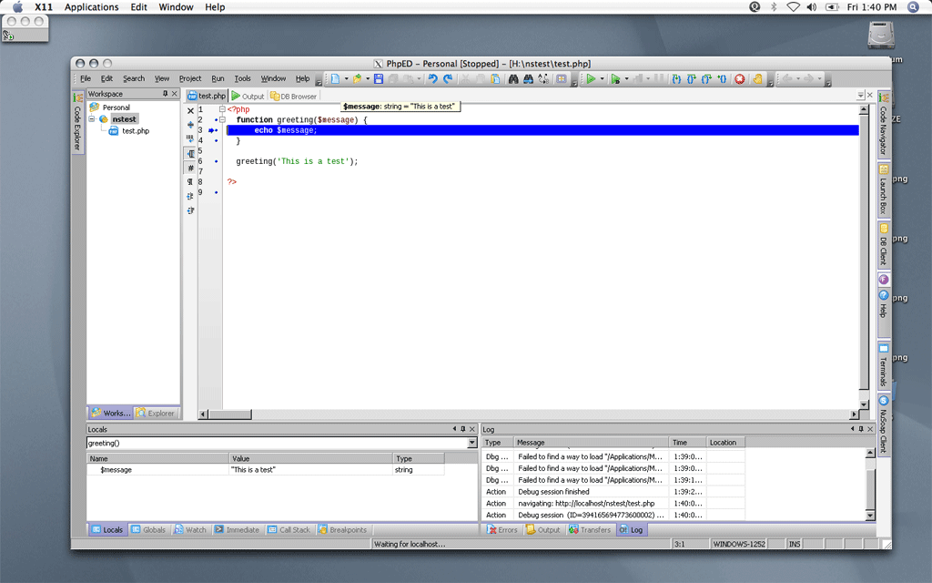

**P2**

***Describe the factors that influence the choice of programming language***

I will be describing the factors that influence the choice of programming language. The factors that I will be talking about is the following: organisational policies; suitability; availability of trained staff; reliability; development and maintenance cost; expandability.

**[](http://www.google.co.uk/url?sa=i&rct=j&q=&esrc=s&frm=1&source=images&cd=&cad=rja&docid=Yaoa5hx06DmOAM&tbnid=aE2NzCGKEd7U1M:&ved=0CAUQjRw&url=http://ljsilentg.com/tag/organisational-policies/&ei=x2OcUpzXIMvQ7AbL_ICoDg&bvm=bv.57155469,d.ZGU&psig=AFQjCNFX5ApoM9S2Ao3D2mfdeXMrG1kpjg&ust=1386067259123562)Organisational policies** are very important for programming companies especially for the big companies. This may determine what they may use and what they may not use. For example, if a policy is that they are only allowed to use Microsoft software for ‘work’ purposes. This may earn more level of support than another software. Another company could have different policies. For example, another company could use Apple Macintosh computers.

**Suitability** could be in set into two different explanations. Is it relevant and suit the type of programme that is going to be written? Will it work? Some programming language is specifically designed for the specific programme. It needs to be suited to whereabouts it is used, how it is used and any codes that have been inserted. For example, Visual Basics only works on a computer. It cannot be run on any other programme. Therefore, it is important the language chosen is correct for the programme that you will make.

**Availability of trained staff** is very important whilst working for a programming company. Because programming is hard, it is hard to find trained staff for the specific language chose. This is a factor when choosing the type of programming language because if the trained staff has studied/knows the language and the company chooses a language that the staff has not studied, it could be a problem. This is why it is important when choosing which type of programming language you are going to use. Even if the company hires a trained staff, they have to adapt from past experience/education to get into the process/learn the programme language the company has chosen. However, the big advantage of choosing the right candidate for a programming job is that it will save a lot of time. They would not need to deal with any hassles of not getting any codes or sort of stuff like that. This is because if any of the staff is unfamiliar with the programming language, you will need to recruit new staff. This factor can affect the programming language.

[](http://www.google.co.uk/url?sa=i&rct=j&q=&esrc=s&frm=1&source=images&cd=&cad=rja&docid=M-6h1lclEq3WsM&tbnid=v_7s0AUvf_wo_M:&ved=0CAUQjRw&url=http://dict.space.4goo.net/dict?q=reliability&ei=WR-fUpXYMYia7QaC0oHoCQ&bvm=bv.57155469,d.ZGU&psig=AFQjCNEykMM4sUtBNxPoutHIzznQPRwHGg&ust=1386246352154228)**Reliability** in a program is as important as other factors effecting the programming language. Every programmer wants to satisfy each of the factor. For example, the best of the language is ADA. If the programmer could use this, they would know that this language is reliable and trustworthy. This a factor that can influence the choice of a programming language, because if the language choice is not reliable enough, the programming company wouldn’t choose it.

[](http://www.google.co.uk/url?sa=i&rct=j&q=&esrc=s&frm=1&source=images&cd=&cad=rja&docid=4YczK8SS4aD2nM&tbnid=u7M1VqPFQ-ZvxM:&ved=0CAUQjRw&url=http://www.fpt-software.com/Service/Application-Services.html&ei=bh2fUsH7BoOr7AasqYCABg&bvm=bv.57155469,d.ZGU&psig=AFQjCNFSdRTyWt46Tje7VH29N65Q2Z3zqQ&ust=1386245859879964)**Development and maintenance cost** is a factor that uses money a lot. Any company wants to develop and maintain programs for a cheap cost. However, it is not that easy because the company has to keep maintaining the program (updating it). Simply, if it was not updated, people would not use it. For a programming company, it’s not easy trying to develop and maintain the program. They would need to maintain it however if they keep on maintaining the program, it could cause more bugs and errors to be fixed. They could use RPG, Report program generator. This was designed to help speed processes of reports. This could reduce the development and maintenance cost of it as this is could be a possible advantage for the company.

As you can see on the picture, everybody wants the quality, speed and efficiency of the program to be great and the cost to be the lowest of them all. They want this as they can have the program cost cheap but satisfy other users for it. This could affect the influence on the programming language because if the cost of the programmes were low, they would not be able to choose the programming language they want.

[](http://www.google.co.uk/url?sa=i&rct=j&q=&esrc=s&frm=1&source=images&cd=&cad=rja&docid=ppAprwqwsMk0RM&tbnid=ogw83J0OvzK97M:&ved=0CAUQjRw&url=http://www.dell.com/us/dfb/p/poweredge-2900/pd&ei=qB-fUsiAM4ap7QaojIHwBA&bvm=bv.57155469,d.ZGU&psig=AFQjCNGHg-inLnKCi1C2TqMNNdX-vsQ3Kw&ust=1386246424500103)**Expandability** is the most important factor of the programming language. The program needs to be expanded so that they have more features so use on the programme. For this unit, only one person will be using the program. However, in a real life situation, many programmers will use the program that is made. It is important choosing the programming language as this may influence the chose because if you are creating a website or an online shop, you need to be aware of if it can support large amounts data.